# A brief summary of my activities, contributions and artifacts I have produced during the past week

Third week of class and finally I started programming on app. As discussed in our team meeting, I was responsible to make App UI, layout structures and couple of pages. One of our team mate Edward, designed some wireframes using a tool and I had to convert them into the reality. Mark started the work on Github and created a project on source control. The entire app follows Material Designing. I used Navigation Drawer for directory purpose and put all the various modules, functions on it. I made couple of pages with sliding tabs using Fragments. Apart from this coding stuffs, I did R&D on [PARSE.COM](http://parse.com/), GCM and Volley library.

1. [PARSE.COM](http://parse.com/)

I personally used GCM – Google Cloud Messaging, to receive push notifications and it was very time consuming and tricky to implement. And later I came to know that, we can do the same using the free push service provided by [Parse.com](http://parse.com/) also.

1. GCM – Google Cloud Messaging

The main use for GCM is that, we can send message/data from our server to client’s devices and we can receive messages/data from the devices on the same connection. It is free. Using this service we can send data to our application whenever new data is available instead of making requests to server in timely fashion.

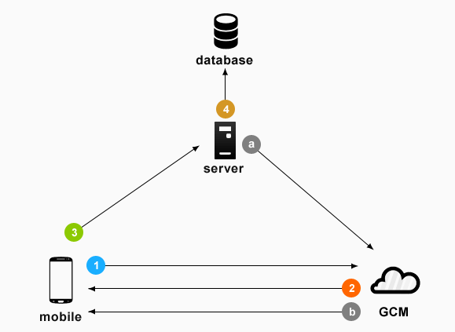

1. Volley library

Android Volley library is a networking library mainly used for making networking call much easier and faster. It works on asynchronous task. So developer don’t have to worry about using asynchronous task anymore. I am planning to use this volley library for prevention mode. Because prevention mode has lot of stuffs like videos, pictures, texts, descriptions and many more so to release load from server, will use volley library.

# My plans, thoughts and reflections on the state of the project for the next week

I think, I’m done with most of the R&D tasks. We decided to fix our preferences and I set my priorities

1. Rewards/Profile
2. Integration & UI
3. IoT – Detection
4. Prevention
5. Appliance Maintenance

Currently, one of our mate is working on Tango card API and their profile access, then we will figure it out how to merge these. My preference is Rewards/Profile but I’m willing to take on any of the features on top of whatever sub-group I’m in. I am waiting for the next wireframe designs and will convert them in to the app screen. Moreover, after getting PI and gimball, I want to start some basic sensor activities on app. It will help me to clear my way to work on this project.

Please scroll down for Screenshots.

Please scroll down for Screenshots.

1. Home Screen of App

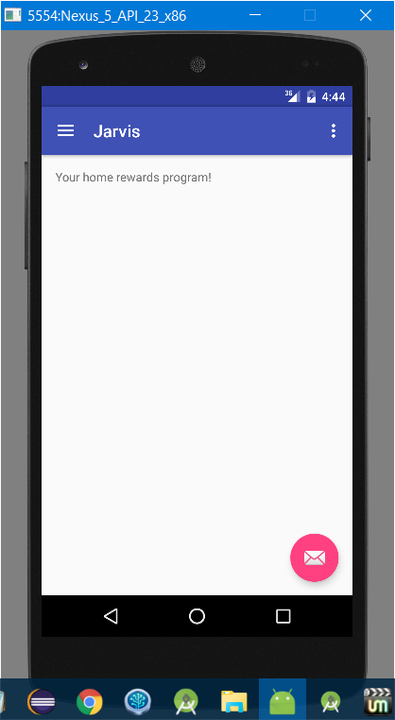

1. Action Bar for an App

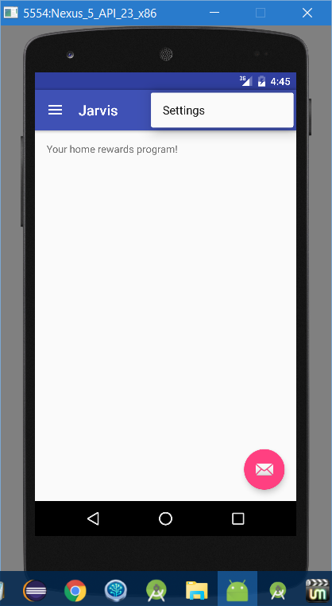

1. Navigation Drawer

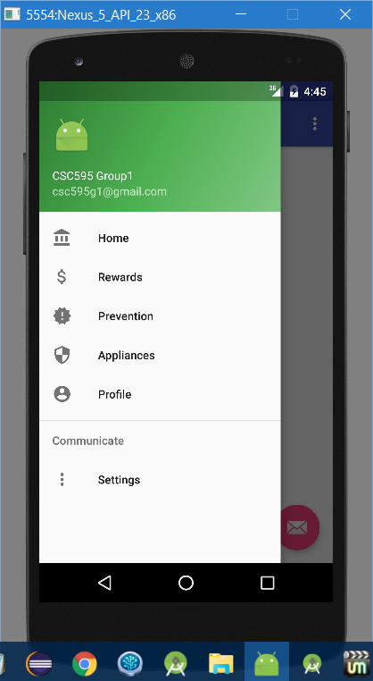

1. Sliding Tabs activity

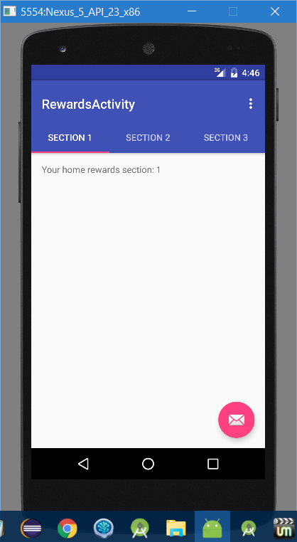

1. Floating Button Activity

